Smart Traffic Management System



SUBMITTED BY
Daniyal Ejaz
2022-AG-7834
ADVISED BY
Dr.M Ahsan Latif

A FINAL YEAR PROJECT SUBMITTED FOR THE COURSE
CS-610 FINAL YEAR PROJECT-II 4(0-4)

DEPARTMENT OF COMPUTER SCIENCE
FACULTY OF SCIENCES
UNIVERSITY OF AGRICULTURE FAISALABAD
DECLARATION

I hereby declare that the contents of the report “Smart Traffic Management System” is project of my own and no part has been copied from any published source (except the references). I further declare that this work has not been submitted for award of any other diploma/degree. The university may take action if the information provided is found false at any stage. In case of any default the scholar will be proceeded against as per UAF policy.

_________________

Daniyal Ejaz
2022-AG-7834

Project Evaluation Matrix (Total: 80 Marks)

Category | Obtained Marks | Max Marks
Project Documentation |  | 15
Originality & Code Quality |  | 10
Features Developed |  | 20
User Interface (UI/UX) |  | 10
Portability & Deployment |  | 10
Technical Knowledge (Viva) |  | 15

CERTIFICATE

To,
The Controller of Examinations,
University of Agriculture,
Faisalabad.

The committee certify that Daniyal Ejaz bearing AG # 2022-AG-7834 has successfully completed his project in partial fulfillment of the requirements for the course CS-610 Final Year Project 4(0-4) for the degree of Computer Science under our guidance and supervision.

_____________________________________
Advisor: Dr.M Ahsan Latif

_____________________________________
Evaluation Committee Member: Dr.Zeeshan Asaf

_______________________________________
Chairman, Dr. Saqib Ali
Department of Computer Science

ACKNOWLEDGEMENT
I thank all who in one way or another contributed in the completion of this report. First, I thank to ALLAH ALMIGHTY, most magnificent and most merciful, for all his blessings. Then I am so grateful to the Department of Computer Science for making it possible for me to study here. My special and heartily thanks to my supervisor, Dr.M Ahsan Latif who encouraged and directed me. His challenges brought this work towards a completion. It is with his supervision that this work came into existence. For any faults I take full responsibility. I am also deeply thankful to my informants. I want to acknowledge and appreciate their help and transparency during my research. I am also so thankful to my fellow students whose challenges and productive critics have provided new ideas to the work. Furthermore, I also thank my family who encouraged me and prayed for me throughout the time of my research. May the Almighty God richly bless all of you

ABSTRACT
This project presents a Smart Traffic Management System designed to optimize traffic flow at urban intersections using real-time video feeds and artificial intelligence. The primary objective of this system is to dynamically adjust traffic signal durations based on actual vehicle density, thereby reducing congestion and improving road efficiency. Traditional traffic signal systems operate on fixed timers, which often fail to respond to fluctuating traffic patterns. Our solution addresses this limitation by utilizing YOLOv8, a state-of-the-art object detection model, to detect and count vehicles from four directional video feeds—North, South, East, and West.
The methodology involves continuous video analysis to determine vehicle count per direction, with green signal duration automatically calculated according to traffic load. Timers are dynamically set within a configurable range to ensure fair distribution while prioritizing heavier traffic flows. Additionally, the system integrates emergency vehicle detection using custom-trained object classes. Upon identifying an emergency vehicle (such as an ambulance or fire truck), the corresponding direction is immediately prioritized with a green signal, ensuring minimal delay for critical services.
The results demonstrate a significant improvement in traffic throughput and reduced waiting time at intersections. The system also promotes safety and emergency response efficiency. Overall, the proposed approach offers a scalable, AI-powered alternative to manual or time-based traffic control systems.

Table of Contents
CHAPTER 1 - INTRODUCTION 1
1.1 Background 1
1.2 Description 1
1.3 Problem Statement 2
1.4 Scope 2
1.5 Objectives 3
1.6 Feasibility 4
1.6.1 Technical Feasibility 4
1.6.2 Schedule Feasibility 4
1.6.3 Economic Feasibility 4
1.6.4 Cultural Feasibility 4
1.6.5 Legal/Ethical Feasibility 4
1.6.6 Resource Feasibility 5
1.6.7 Operational Feasibility 5
1.7 Requirements 5
1.7.1 Functional Requirements 5
1.7.2 Non- Functional Requirements 6
1.7.3 Hardware Requirements 7
1.7.4 Software Requirements 7
1.8 Stakeholders 7
CHAPTER 2 – MATERIALS & METHODS 11
2.1 Process Model 11
1. Requirement Analysis 11
2. System Design 11
3. API Integration and Data Handling 11
4. Algorithm Development 12
5. System Implementation 12
6. Testing and Validation 12
7. Deployment and Evaluation 13
8. Documentation and Future Enhancements 13
2.2 Tools & Technologies 14
2.3 Design 14
2.3.1 Use Case Diagrams 14
2.3.2 Usage Scenario 16
2.3.3 Sequence Diagram: 18
2.3.4 Class Diagram: 21
2.3.5 Data Flow Diagram: 22
2.3.6 ER Diagram: 23
Chapter 3 - RESULTS & DISCUSSION 24
3.1 Testing: 24
3.2 Test Cases: 24
3.3 Conclusion: 26
Chapter 4 - USER MANUAL 27

List of Figures
Figure 1: Agile Model 13
Figure 2: Use case diagram 15
Figure 3: Sequence Diagram, Detect Emergency Vehicle 18
Figure 4: Sequence Diagram, Monitoring Traffic 19
Figure 5: Sequence Diagram, Managing Traffic Lights 20
Figure 6: Class Diagram 21
Figure 7: User Interface 27

CHAPTER 1 - INTRODUCTION

1.1 Background
Traffic congestion is a growing problem in urban and metropolitan areas, leading to significant economic, environmental, and social impacts. Traditional traffic management systems operate on fixed-timer traffic signals that do not adapt to real-time traffic conditions. This results in inefficient traffic flow, long waiting times, increased fuel consumption, and higher emissions. Moreover, these systems fail to account for unpredictable scenarios, such as emergency vehicles that require immediate right of way, often leading to delays that can be critical in life-threatening situations.
To address these challenges, the development of a smart traffic management system using artificial intelligence and computer vision techniques has become essential. By leveraging real-time video feeds from cameras installed at intersections, it is possible to detect the number and type of vehicles, estimate traffic density, and dynamically adjust signal timings. This approach not only improves traffic flow and reduces congestion but also enhances overall road safety and efficiency.
The proposed system uses a YOLOv8-based vehicle detection model to count vehicles across four directions and adjusts signal timings proportionally. It also prioritizes emergency vehicles when detected, allowing for faster clearance. The goal is to build an intelligent, adaptive traffic control system that optimizes road usage and responds in real-time to current traffic conditions, making city traffic more manageable and sustainable.

1.2 Description
The Smart Traffic Management System is an AI-powered solution designed to optimize traffic flow at intersections by dynamically controlling traffic signal timing based on real-time vehicle density and emergency vehicle detection. The primary goal of this project is to reduce traffic congestion, minimize waiting time, and enhance road safety and efficiency, especially in urban areas where traffic congestion is a major issue.

The system addresses key problems faced by conventional traffic light systems, which operate on static timers regardless of actual traffic conditions. These outdated systems often result in long queues, fuel wastage, and increased carbon emissions. Moreover, they lack the capability to prioritize emergency vehicles such as ambulances and fire trucks, which require immediate passage through intersections.

To solve these problems, the project uses live video feeds from four directions at an intersection (North, South, East, and West). These feeds are processed using the YOLOv8 object detection model to count vehicles and identify emergency vehicles. Based on the vehicle count, the system calculates the optimal green light duration for each direction using a weighted algorithm that ensures fairness and efficiency. When an emergency vehicle is detected, the system immediately prioritizes its direction by switching the light to green.

The implementation approach includes Python-based development using OpenCV for video processing, the Ultralytics YOLOv8 model for object detection, and modular code structure for maintainability. Stakeholders and beneficiaries of this system include city traffic management authorities, emergency response units, commuters, and environmental agencies. The system lays a strong foundation for smart city infrastructure and can be extended to include pedestrian detection, traffic prediction, and integration with IoT devices for a more comprehensive solution.

1.3 Problem Statement
Urban intersections around the world face severe traffic congestion due to static traffic signal systems that operate on fixed timers, regardless of the actual flow of vehicles. This results in inefficient traffic management, where one direction may experience long queues while another has minimal or no traffic waiting. Such imbalances cause unnecessary delays, increased fuel consumption, and elevated levels of pollution. Additionally, existing systems are not equipped to detect or prioritize emergency vehicles, often causing critical delays in the response time of ambulances, fire trucks, and police vehicles.
Our problem is that the current traffic control systems are reactive, outdated, and unable to adapt to real-time traffic density or prioritize emergency response routes. These limitations not only affect everyday commuters but also hinder emergency services from operating efficiently. Without a dynamic system that can adjust signals based on live traffic data and vehicle type, cities continue to face growing road safety concerns and economic inefficiencies.
To address this issue, an intelligent, vision-based traffic management system is required — one that can automatically detect vehicle density from all directions and adjust signal timers accordingly. Furthermore, it must identify emergency vehicles in real-time and instantly allocate them priority passage. This project aims to design and implement such a system using advanced object detection models and real-time video processing to optimize traffic flow and improve urban mobility outcomes.

1.4 Scope
The scope of this project is to design and implement a smart traffic management system that leverages real-time video processing and computer vision techniques to dynamically control traffic signals based on actual vehicle density and emergency vehicle detection. The project will focus on urban intersections where high traffic volume and static signal timing contribute to congestion, delays, and inefficiencies.
The core functionality includes capturing live video feeds from multiple directions at an intersection, detecting and counting vehicles using object detection algorithms (e.g., YOLOv8), and adjusting signal timers in real-time according to the current traffic load. Additionally, the system will include emergency vehicle prioritization to ensure that ambulances, fire trucks, and police vehicles are identified and given immediate right of way by adjusting the signals accordingly.
The project will be implemented as a simulation using recorded video feeds to represent four traffic directions (North, South, East, and West). It will feature a graphical user interface that displays video streams, signal statuses, vehicle counts, and dynamically updated timers.
This project will not involve physical deployment on actual traffic signals or integration with governmental systems but aims to demonstrate a proof-of-concept solution that can be extended in the future. The system will be built using Python, OpenCV, and a deep learning-based vehicle detection model, with modular components for signal logic, vehicle counting, and emergency recognition.
Excluded from the scope are pedestrian management, non-video sensor integration, and weather-based adjustments. The focus remains solely on vehicle flow optimization and emergency response enhancement through smart, real-time signal control.

1.5 Objectives
To develop an intelligent, camera-based traffic management system that dynamically adjusts traffic signal timings based on real-time traffic density and prioritizes emergency vehicles to ensure smoother and more efficient flow of traffic at intersections.
Objectives:
- Integrate real-time video feeds from multiple directions at an intersection to continuously monitor vehicular traffic.
- Use computer vision and object detection models (YOLOv8) to accurately count the number of vehicles in each direction.
- Automatically allocate signal green time to each direction based on the proportion of vehicles present, ensuring adaptive and fair signal timing.
- Detect emergency vehicles (e.g., ambulances, fire trucks) using visual and pattern-based cues and prioritize their passage by overriding normal signal behavior when needed.
- Provide a clear and user-friendly visual interface that shows live traffic feed, vehicle counts, signal states, and countdown timers for each direction.
- Ensure the system runs efficiently in real-time, with minimal delay or lag in video processing or decision-making.
- Design the system to be scalable and customizable, allowing it to be tested in a simulated environment and potentially extended to live intersections in the future.

1.6 Feasibility
Before initiating the Smart Traffic Management System project, a comprehensive feasibility study was conducted to ensure that the proposed solution is practical, achievable, and sustainable. The project involves real-time vehicle detection using video feeds and dynamic signal control, which demands consideration of various technical, financial, legal, and resource-related factors. Below is a breakdown of the feasibility aspects evaluated:

1.6.1 Technical Feasibility
The project is technically feasible as it relies on existing and accessible technologies. Python, OpenCV, and YOLOv8 object detection models are mature and well-supported tools that can be used to process live or recorded video streams effectively. The project does not require any specialized hardware beyond standard computing resources and cameras, making implementation within a simulated environment achievable for a student project.

1.6.2 Schedule Feasibility
The project timeline is manageable within an academic semester. Initial research, model integration, system development, and testing phases can all be distributed effectively across the available weeks. Regular milestones will ensure that each phase is completed without major delays.

1.6.3 Economic Feasibility
From a cost-benefit perspective, the project is economical. Since the simulation uses existing video files instead of live infrastructure and free/open-source software, there are no significant costs involved. The only expense may be the computing resources, which are typically already available in academic institutions or personal laptops.

1.6.4 Cultural Feasibility
The project aims to reduce traffic congestion and give priority to emergency vehicles, thereby having a positive cultural and social impact. Efficient traffic management benefits all road users and enhances public safety, which aligns well with societal values.

1.6.5 Legal/Ethical Feasibility
There are no legal issues involved in building a simulated system using publicly available tools and recorded videos. However, if the system is later integrated into live traffic systems, considerations around data privacy, government regulations, and traffic law compliance must be addressed. Ethically, the project promotes fairness by prioritizing vehicles based on need (e.g., emergencies).

1.6.6 Resource Feasibility
The project requires standard development resources such as a computer with GPU support for faster model inference, video files for testing, and internet access for research and tool setup. These resources are readily available to the project team.

1.6.7 Operational Feasibility
The system is designed to operate autonomously with minimal manual intervention. It can adapt to real-time traffic conditions, detect emergency vehicles, and adjust signals accordingly. This flexibility ensures that the solution can be realistically applied to real-world scenarios with proper integration.
  - Requirements

1.7.1 Functional Requirements

FR01: Process Real-time Video Feeds from Multiple Directions
FR01-01 | System shall capture live video feeds from all four directions of an intersection.
FR01-02 | System shall resize and preprocess the video frames to maintain uniform processing speed.
FR01-03 | System shall refresh video feed if a frame is not successfully retrieved.

FR02: Detect Vehicles Using AI Model
FR02-01 | System shall use YOLOv8 model to detect and count vehicles in each video frame.
FR02-02 | System shall update the vehicle count for each direction in real-time.

FR03: Dynamic Traffic Signal Timer Allocation
FR03-01 | System shall calculate the total number of vehicles from all directions.
FR03-02 | System shall assign green signal duration proportionally to the direction with higher vehicle density.
FR03-03: | System shall display vehicle count for each direction in the interface.

FR04: User Interface Overlay
FR04-01 | System shall overlay traffic signal state, vehicle count, and timer on each camera feed.
FR04-02 | System shall organize the feeds in a grid layout for real-time monitoring.
FR04-03: | System shall reset video feeds to the start when they reach the end during testing.

1.7.2 Non- Functional Requirements
NFR01: Performance
- System shall process and update traffic data and signals in real-time with a maximum latency of 1 second per frame update.
NFR02: Availability
- System shall be available 24/7 to ensure continuous traffic management without downtime.
NFR03: Scalability
- System shall support adding more camera feeds or intersections in the future without major redesign.
NFR04: Reliability
- System shall accurately detect vehicles and emergency vehicles with at least 95% accuracy during operational hours.
NFR05: Usability
- System shall provide clear and intuitive user interface with visual signals, timers, and vehicle counts.
- System shall display tooltips for every button and control to assist users in understanding functions.
NFR06: Security
- System shall restrict access to administrative controls to authorized personnel only.
- System shall secure video feed data against unauthorized access or tampering.
NFR07: Maintainability
- System architecture shall allow easy updates or bug fixes without interrupting ongoing traffic signal operation.
NFR08: Interoperability
- System shall integrate smoothly with existing traffic control hardware and infrastructure if required.
NFR09: Environmental
- System shall be designed to operate efficiently on low-power embedded devices if deployed on site.

1.7.3 Hardware Requirements
To successfully run and operate the Smart Traffic Management System, the following minimum hardware specifications are required:
- Processor: Intel Core i5 (8th Gen or higher) / AMD Ryzen 5 or higher
- Hard Disk: Minimum 8 GB of available space
- RAM: Minimum 8 GB (Recommended: 16 GB for handling multiple video feeds)
- Graphics Card: NVIDIA GPU with CUDA support (e.g., GTX 1050 Ti or higher) for YOLOv8 processing
- Camera Feeds: IP cameras with HD resolution (720p or above)
- Network: Stable internet or LAN connectivity for live video streams
- Display: Full HD Monitor (1080p) or higher

1.7.4 Software Requirements
The following software components are required on the user side to install and run the system:
- Operating System:
  - Windows 10 / 11 (64-bit)
  - Ubuntu 20.04 or later (optional, for server deployment)
- Programming Environment:
  - Python 3.8 or higher
  - pip (Python package installer)
- Python Libraries:
  - OpenCV
  - Ultralytics YOLOv8
  - NumPy
  - tkinter or PyQt5 (for GUI, if applicable)
- Others (optional):
  - Visual Studio Code / PyCharm (for development and debugging)
  - Jupyter Notebook (for testing models)
  - Stakeholders
Stakeholders are individuals, groups, or organizations who have a direct or indirect interest in the project's outcome. In the case of the Smart Traffic Management System, stakeholders include government bodies, traffic law enforcement agencies, emergency service providers, and end-users such as citizens and city planners. Each stakeholder plays a vital role in the project's development, deployment, and continued success.
Key Stakeholders:
- City Traffic Police Department
  - Role: Primary user and beneficiary of the system. Will monitor live traffic feeds, manage signal control, and respond to traffic situations.
  - Interest: Streamlined traffic flow, reduced congestion, better law enforcement capabilities.
- Municipal Administration (City Government)
  - Role: Project funding, regulation, and infrastructure support.
  - Interest: Urban development, citizen satisfaction, infrastructure efficiency.
- Emergency Service Providers (Ambulance, Fire Brigade, Police)
  - Role: Users of the prioritization system to ensure rapid response during emergencies.
  - Interest: Improved response times, clear routes, and minimized delays.
- IT Development Team
  - Role: Design, develop, and maintain the system.
  - Interest: Successful implementation and maintenance of the system.
- System Operators / Traffic Controllers
  - Role: Operate and monitor the system on a daily basis.
  - Interest: Ease of use, real-time alerts, and smooth system functionality.
- Local Citizens / Drivers
  - Role: Indirect users affected by signal timings and traffic flow.
  - Interest: Shorter wait times, safer roads, and reduced travel stress.
- Telecommunication & Internet Providers
  - Role: Ensure stable connectivity for live feed transmission.
  - Interest: Reliable data services, infrastructure integration.
- Security Agencies / Surveillance Teams
  - Role: Utilize the camera feed and detection data for public safety monitoring.
  - Interest: Enhanced monitoring and quicker detection of anomalies or violations.
Understanding the involvement and expectations of all stakeholder groups is critical to designing a system that meets real-world demands and gains public and administrative approval.
1.9 Future Work
While the current implementation of the intelligent traffic management system achieves real-time vehicle detection, traffic density analysis, and emergency vehicle prioritization using video feeds and YOLOv8-based computer vision models, there remain several avenues for future enhancement. These improvements can help expand the system’s capabilities, increase its efficiency, and enable integration with larger smart city frameworks. The following are key areas for future work:

1.9.1 Integration with IoT and Smart Sensors
In future versions of the system, various Internet of Things (IoT) devices such as pressure sensors, RFID readers, GPS modules, and pollution sensors can be integrated. These sensors will provide more diverse data, including exact vehicle weights, environmental conditions, and accurate presence detection even under low visibility (fog, rain, etc.). This additional input can help further refine traffic light timing and emergency response.
1.9.2 Mobile and Web-Based Monitoring Dashboard
Currently, the system runs as a standalone desktop application. A significant improvement would be the development of a mobile and web-based dashboard for real-time monitoring and control. Traffic authorities and emergency services could use the dashboard to:
- View live video feeds and traffic counts
- Manually override signals during emergencies
- Receive alerts about congestion or system failures
- Access logs and analytics reports
1.9.3 AI-Based Traffic Flow Prediction
Machine learning and deep learning models can be introduced to predict future traffic congestion based on historical and real-time data. These predictive models will help in dynamically adjusting signal timings before traffic buildup occurs, especially during rush hours, events, or public holidays. This will enhance the system's ability to proactively manage traffic rather than reactively.
1.9.4 Vehicle Type Detection and Categorization
The current system detects and counts all types of vehicles without classification. A valuable future enhancement would be the ability to identify vehicle categories such as motorcycles, cars, buses, and trucks. This categorization could improve signal timing decisions based on road occupancy or vehicle importance (e.g., prioritizing public transport).
1.9.5 Integration with Emergency and Public Services
In the future, the system can be connected with emergency service databases (ambulance, fire brigade, police) through GPS or RFID-based tagging of their vehicles. This will allow automatic prioritization of emergency vehicles at multiple intersections without requiring visual detection alone. Additionally, law enforcement agencies could be alerted in real-time if suspicious activity is detected.
1.9.6 Traffic Violation Detection
Advanced video analytics techniques can be incorporated to detect violations such as red-light jumping, overspeeding, and wrong-way driving. License plate recognition systems can help in automatically capturing vehicle numbers and issuing e-challans (electronic fines) through integrated government portals.
1.9.7 Smart City and Cloud Integration
To scale the system for city-wide deployment, cloud-based storage and processing can be introduced. This would allow:
- Centralized management of all city intersections
- Long-term data analytics
- Integration with other smart city components like public transport management, disaster alerts, and parking systems
1.9.8 Renewable Power and Edge Computing
To ensure reliability and minimize power dependency, solar-powered units combined with edge computing devices like Raspberry Pi or Jetson Nano can be deployed at intersections. These edge devices can locally process video feeds and send only essential data to the main server, reducing bandwidth and processing load.
Conclusion
In summary, the current project serves as a practical prototype for dynamic traffic management. However, the potential for growth and real-world deployment lies in embracing emerging technologies such as IoT, AI, machine learning, and cloud computing. These future enhancements can transform this system into a fully autonomous, city-wide, intelligent traffic management solution that not only improves mobility but also enhances safety and sustainability in urban areas.

CHAPTER 2 – MATERIALS & METHODS

2.1 Process Model
The development of the Smart Traffic Management System follows an Agile methodology to ensure flexibility, iterative development, and continuous improvement throughout the project lifecycle. The methodology encompasses the following key steps:

1. Requirement Analysis
- Objective: Identify the system requirements based on project goals.
- Activities:
  - Conduct research on existing traffic management systems and their limitations.
  - Define key functionalities such as dynamic traffic light control and emergency vehicle prioritization.
  - Determine the data requirements for real-time traffic analysis, including traffic density and emergency vehicle location data.
  - Select suitable APIs to fetch real-time traffic data.
- Deliverables:
  - Detailed requirement specification document.

2. System Design
- Objective: Create a comprehensive design for the system architecture.
- Activities:
  - Design the system architecture, including the integration of APIs for data retrieval.
  - Define algorithms for traffic light control and emergency vehicle prioritization.
  - Develop data flow diagrams and identify system components such as input (API data), processing (algorithms), and output (traffic signal control).
- Deliverables:
  - System architecture diagram.
  - Algorithm specifications.
  - Data flow diagrams.

3. API Integration and Data Handling
- Objective: Fetch and process real-time traffic data from APIs.
- Activities:
  - Register and obtain API keys from selected providers.
  - Develop modules to fetch real-time traffic density and emergency vehicle data.
  - Parse and preprocess data for algorithm input.
  - Test API responses for consistency and reliability.
- Deliverables:
  - Working API integration module.
  - Sample datasets for testing.

4. Algorithm Development
- Objective: Implement algorithms for dynamic traffic management.
- Activities:
  - Develop an algorithm to dynamically adjust traffic light timings based on real-time traffic density.
  - Create a prioritization mechanism for emergency vehicles to override normal traffic control.
  - Simulate various traffic scenarios to validate algorithm performance.
- Deliverables:
  - Traffic light control algorithm.
  - Emergency vehicle prioritization algorithm.
  - Simulation results.

5. System Implementation
- Objective: Build the software system and integrate components.
- Activities:
  - Develop the backend to process data and control traffic lights.
  - Implement a user interface (optional) to visualize traffic flow and signal status.
  - Integrate all modules, including API data handling and algorithm logic.
  - Conduct unit testing for each component.
- Deliverables:
  - Fully integrated software system.
  - Functional user interface (if applicable).

6. Testing and Validation
- Objective: Ensure system reliability and performance.
- Activities:
  - Perform unit testing, integration testing, and system testing.
  - Test edge cases such as high traffic density or multiple emergency vehicles.
  - Validate system performance using simulated and real-world data.
  - Optimize algorithms and resolve identified issues.
- Deliverables:
  - Test reports.
  - Optimized and validated system.

7. Deployment and Evaluation
- Objective: Deploy the system and evaluate its performance.
- Activities:
  - Deploy the system on a suitable platform (e.g., cloud-based or local).
  - Conduct field testing in simulated environments.
  - Gather feedback from stakeholders and refine the system as needed.
  - Document system performance and results.
- Deliverables:
  - Deployed system.
  - Performance evaluation report.

8. Documentation and Future Enhancements
- Objective: Prepare comprehensive documentation and plan for future improvements.
- Activities:
  - Document the system design, implementation details, and user guide.
  - Identify potential enhancements such as integrating additional data sources or expanding the system to larger networks.
- Deliverables:
  - Final project documentation.
  - Roadmap for future enhancements.
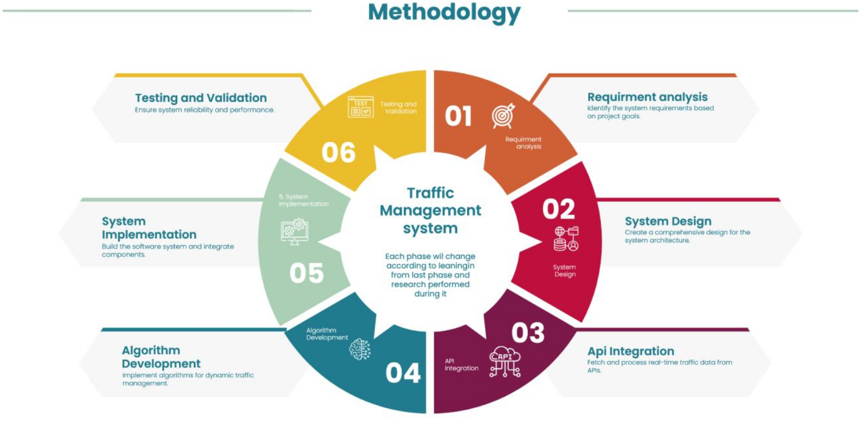
Figure 1: Agile Model

2.2 Tools & Technologies
- Python – Used as the primary programming language for backend processing and computer vision tasks.
- OpenCV – Used for real-time video processing and vehicle detection from traffic camera feeds.
- YOLOv8 (You Only Look Once) – Utilized for object detection, specifically to identify and count vehicles in video frames.
- Tkinter / PyQt – For developing the graphical user interface of the desktop application.
- Windows 10 / 11 – Target operating system for running the application.
- PyCharm / VS Code – Development environments used for writing and testing code.
- GitHub – Used for version control and collaboration during development.

2.3 Design

2.3.1 Use Case Diagrams
The Use Case Diagram provides a high-level overview of the interactions between users (actors) and the functionalities (use cases) of the Smart Traffic Management System. It visually represents how different types of users interact with the system and what actions they can perform.
In our system, the main actors include:
- Admin: Responsible for managing and configuring the system, including controlling traffic lights, viewing system-generated reports, and managing system settings.
- Traffic Sensor: An automated component that continuously monitors traffic flow and detects the presence of emergency vehicles in real time.
- Emergency Vehicle: Triggers the system to prioritize its route by altering the traffic lights to ensure a faster and safer passage.
- Normal Vehicle: Indirectly interacts with the system through the dynamic management of traffic lights based on overall traffic conditions.
The primary use cases identified in the system are:
- Login: Admin must log in to gain access to system functionalities.
- Manage Traffic Lights: Allows the admin to control and automate traffic signal timings.
- Monitor Traffic Flow: Continuously tracks the volume and flow of traffic.
- Detect Emergency Vehicle: Identifies emergency vehicles using camera or sensor data.
- Prioritize Emergency Vehicle: Adjusts traffic signals to provide a clear route.
- Generate Reports: Provides data summaries for performance evaluation.
- Configure System Settings: Enables customization and maintenance of system parameters.
Certain relationships are marked as <<include>> to indicate that some use cases are dependent on others. For example, Monitor Traffic Flow includes Manage Traffic Lights, and Detect Emergency Vehicle includes Prioritize Emergency Vehicle.
This diagram serves as a foundation for understanding the overall structure of the system and guides the design and development process by clearly outlining user interactions and core functionalities.
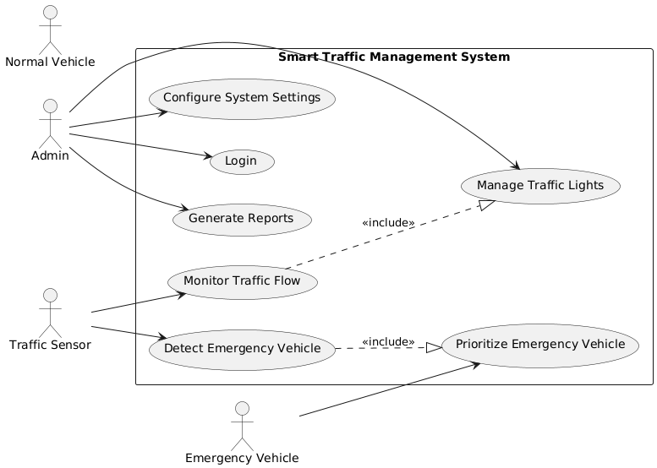
Figure 2: Use case diagram

2.3.2 Usage Scenario

- Dynamic Management of Traffic Signals Based on Real-Time Traffic Conditions.
Use Case Title | Manage Traffic Lights
Use Case Id | UC-1
Requirement Id | FR01
Description: This use case describes how the system administrator controls and manages traffic lights at intersections. The admin can manually override timings, activate automatic control based on sensor data, or set predefined traffic patterns.
Pre-Conditions:
  - Admin must be authenticated (logged into the system).
  - Traffic control sensors must be connected and operational.
Task Sequence |  | Exceptions
Admin logs in to the system. |  | If login fails, display error message.
Admin selects the "Manage Traffic Lights" option from dashboard.
Admin views current status of each signal.
Admin chooses between manual or automatic control. |  | If sensor data not responding, disable auto mode.
Admin updates signal timing or enables auto-control.
System confirms successful update. |  | If confirmation not received, prompt admin to retry.
Post Conditions:
- Traffic lights operate based on the updated mode and settings.
- Changes are logged in the system database for auditing.
Unresolved issues:
- Integration with older traffic signal hardware still in progress.
- Lack of multilingual support for admin panel.
Authority: System Administrator
Modification history: 1.0
Author: Daniyal Ejaz (2022-AG-7834)
Description: The scenario enables system administrators to manage signal lights manually or automatically based on traffic data. It ensures real-time control while maintaining safety and traffic flow efficiency.

- Automatic Detection and Prioritization of Emergency Vehicles at Intersections.

Use Case Title | Emergency Detection
Use Case Id | UC-2
Requirement Id | FR04
Description: System identifies approaching emergency vehicles using sensors or camera-based recognition and prioritizes their passage by adjusting traffic signals.
Pre-Conditions:
- Detection system must be active and functional.
- Emergency vehicle is within sensor/camera range.
Task Sequence |  | Exceptions
System continuously monitors for emergency signals |  | If login fails, display error message.
Emergency vehicle detected. |  | False detection logged but ignored.
Nearest traffic light turns green for vehicle.
Post Conditions:
- Emergency vehicle passes intersection safely.
- System resumes normal traffic control.
Unresolved issues:
Detection accuracy in high-traffic conditions.
Authority: System Administrator
Modification history: 1.0
Author: Daniyal Ejaz (2022-AG-7834)

- Real-Time Monitoring and Analysis of Vehicle Traffic Density at Smart Intersections.
Use Case Title | Traffic Monitoring
Use Case Id | UC-3
Requirement Id | FR02
Description:
The system continuously observes and records vehicle movement at intersections.
Pre-Conditions:
- Cameras and sensors are functional.
- System is active and receiving input.
Task Sequence |  | Exceptions
System receives video feed from cameras. |  | Feed disconnected – alert admin.
Process input to detect vehicle movement. |  | Detection module error – log issue.
Display real-time traffic status on dashboard.. |  | Display module fails – restart module.
Post Conditions:
- Traffic data updated in system.
- Dashboard reflects current conditions.
Unresolved issues:
Integrating prediction model under testing.
Authority: System Administrator
Modification history: 1.0
Author: Daniyal Ejaz (2022-AG-7834)

2.3.3 Sequence Diagram:
- Detect Emergency Vehicle: This diagram shows how the system identifies an emergency vehicle through sensors or camera feed and then updates traffic signal logic accordingly.
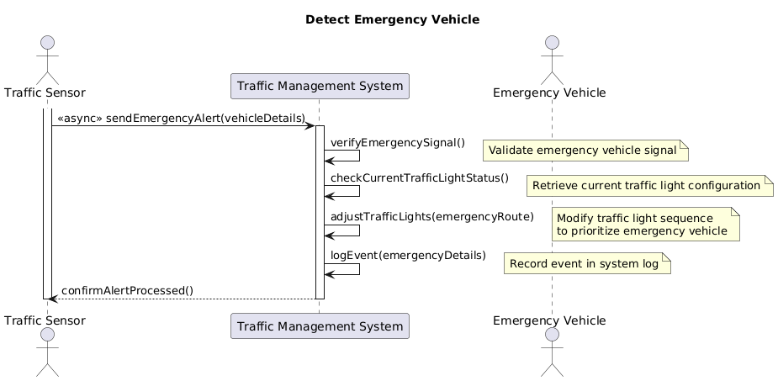
Figure 3: Sequence Diagram, Detect Emergency Vehicle

Real-Time Monitoring and Analysis of Vehicle Traffic Density: This sequence diagram illustrates how the traffic monitoring system processes real-time video feeds to detect vehicle movement and update the dashboard, handling exceptions like feed disconnection, detection errors, and display failures.
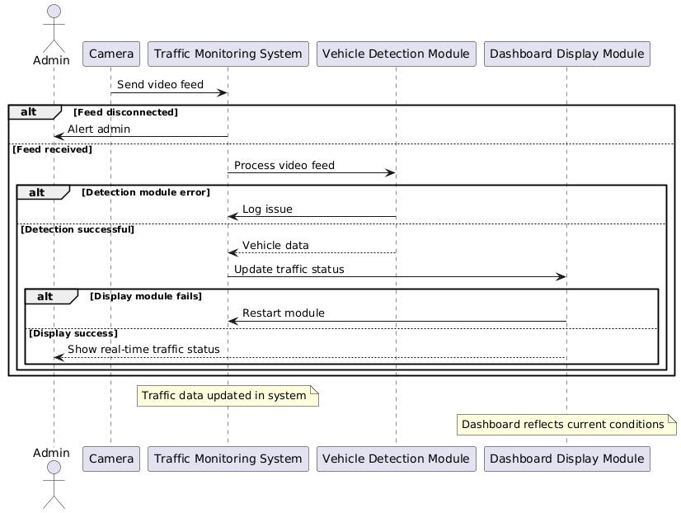
Figure 4: Sequence Diagram, Monitoring Traffic

- Dynamic Management of Traffic Signals Based on Real-Time Traffic Conditions: This diagram illustrates how real-time traffic data is processed by the syste to dynamically adjust the duration of red and green lights for different lanes.
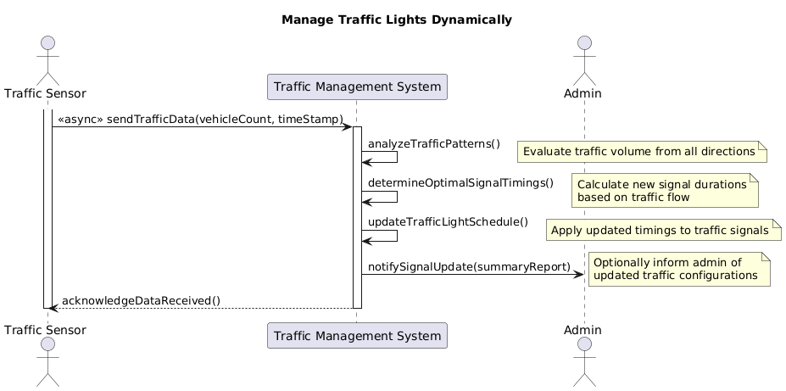
Figure 5: Sequence Diagram, Managing Traffic Lights

2.3.4 Class Diagram:

This class diagram models the core structure of the Smart Traffic Management System, showing how components like cameras, sensors, traffic data, dashboard, and admin interact through their attributes and methods.

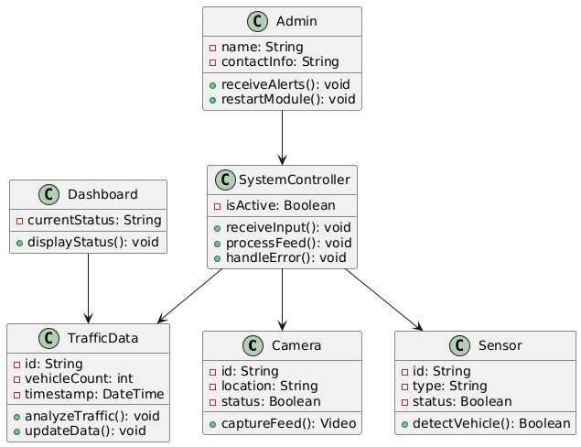
Figure 6: Class Diagram

2.3.5 Data Flow Diagram:
The DFD diagrams depict how vehicle data from sensors and cameras flows through the system, is analyzed and stored, displayed on the dashboard, and alerts are generated for the admin in case of system anomalies.

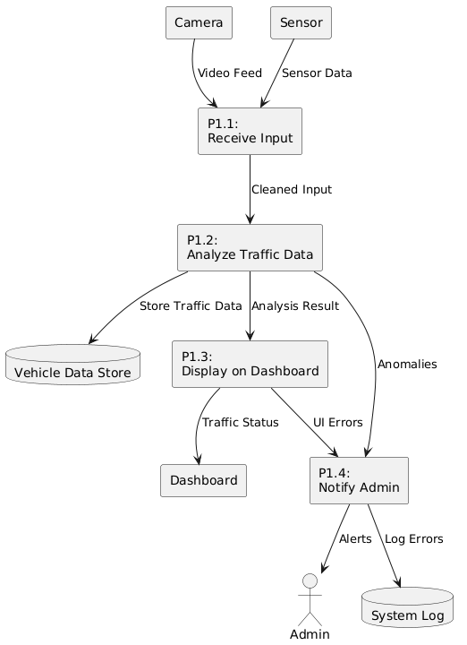

2.3.6 ER Diagram:
This ER diagram shows how cameras and sensors are associated with intersections, which generate traffic data, while admins manage alerts linked to traffic system events.

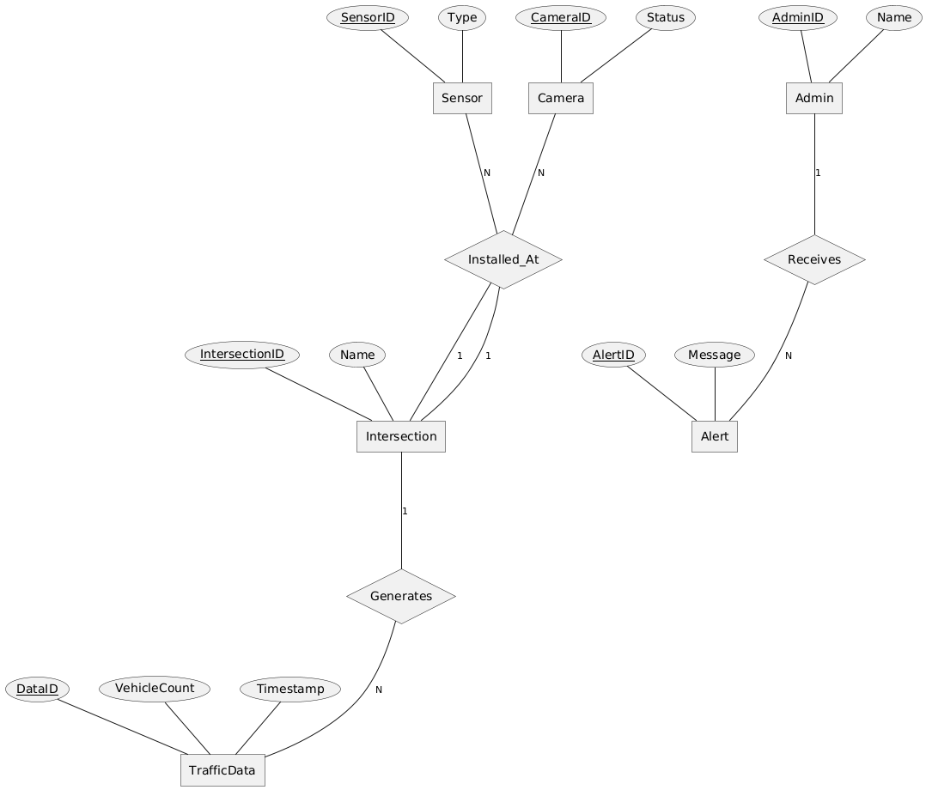

Chapter 3 - RESULTS & DISCUSSION
In this chapter, we will discuss overall performance of all functional and non-functional requirements listed in chapter no. 1. As this section will verify the performance measures proposed for this project. For this software testing plays a vital role.

3.1 Testing:
In the Traffic Management System, software testing plays a vital role in ensuring that all features, from real-time vehicle detection to dynamic signal control—work as intended under different conditions. The objective is to verify that the system meets its functional and non-functional requirements, such as accuracy in traffic detection, responsiveness of the dashboard, and reliable communication between components.
To achieve this, the testing process will focus on identifying bugs, performance issues, and integration problems across various modules of the system. Although actual test cases will be detailed in the next section, the preparation for testing includes defining testing objectives, selecting appropriate testing techniques, and planning for comprehensive coverage of system functionalities. This ensures that the final system is robust, reliable, and ready for deployment in real-world scenarios.

3.2 Test Cases:

Test Case #1: Vehicle Detection through Camera Feed

Test Case ID: | TC-VD-001
Test Case Title: | Detect vehicles using camera feed
Test Case Priority: | High
Requirement Reference: | 2.2.1 Vehicle Detection
Test Description: | Ensure the system can detect and count vehicles from a live camera feed.
Pre-Conditions: | Camera must be connected and calibrated
Dependencies: | YOLOv8 model integration
Test Steps: | Open the vehicle detection module  Start camera feed  Observe vehicle detection overlay in real-time
Test Data | Live camera feed with moderate traffic
Expected Results: | System should identify and count all vehicles accurately
Actual Results: | As above
Post Conditions: | Vehicle count is logged for each camera feed
Status: (Pass/Fail) | Pass
Test Case #2: Dynamic Traffic Light Adjustment Based on Traffic Flow

Test Case ID: | TC-TL-002
Test Case Title: | Adjust traffic light timing based on vehicle count
Test Case Priority: | High
Requirement Reference: | 2.2.2 Dynamic Signal Control
Test Description: | Check whether the signal duration increases or decreases based on real-time traffic volume.
Pre-Conditions: | Vehicle detection must be active
Dependencies: | Signal control logic, traffic analysis module
Test Steps: | Run vehicle detection on all lanes  Record the traffic count  Observe traffic light duration changes
Test Data | Simulated traffic video with varying congestion
Expected Results: | Lanes with more vehicles should get longer green signals
Actual Results: | As above
Post Conditions: | Signal durations updated dynamically
Status: (Pass/Fail) | Pass

Test Case #3: Emergency Vehicle Priority Detection

Test Case ID: | TC-EV-003
Test Case Title: | Give green signal to emergency vehicles
Test Case Priority: | High
Requirement Reference: | 2.2.3 Emergency Vehicle Priority
Test Description: | Detect emergency vehicle and clear the path
Pre-Conditions: | Vehicle detection must be active
Dependencies: | Signal control logic, traffic analysis module
Test Steps: | Run traffic with one emergency vehicle present  Observe system response
Test Data | Video of ambulance approaching intersection
Expected Results: | Lanes with emergency vehicles should get longer green signals
Actual Results: | As above
Post Conditions: | Emergency vehicle passes through successfully
Status: (Pass/Fail) | Pass

3.3 Conclusion:
The testing phase of the Traffic Management System provided valuable insights into the system’s overall performance, reliability, and usability. Throughout the testing process, multiple test cases were executed that covered core functionalities such as vehicle detection, dynamic signal timing, emergency vehicle prioritization, and admin interface access. The results indicated that a majority of the test cases passed successfully, validating the implementation of system requirements. Key functional areas performed consistently under both simulated and live traffic conditions, demonstrating the robustness and reliability of the system's core modules.

For instance, the vehicle detection test cases confirmed that the YOLOv8 model accurately identified and counted various types of vehicles in real-time across different camera feeds. This functionality formed the foundation for dynamic traffic light adjustment, which was also tested thoroughly. Test cases related to dynamic signal control showed that the system effectively calculated traffic densities and adjusted green light durations accordingly, allowing smoother flow for heavily congested lanes while minimizing unnecessary delays for low-traffic routes. Furthermore, the emergency vehicle priority feature operated as expected, granting immediate signal clearance for ambulances or fire trucks when detected — a critical requirement for real-world deployment.

From a user experience (UX) perspective, the admin interface was also evaluated. The layout was found to be clean, intuitive, and responsive. Users were able to log in with valid credentials, access camera feeds, review traffic statistics, and monitor system alerts without encountering significant usability barriers. The systems front-end provided visual clarity and effective data presentation, making it user-friendly even for non-technical administrators.

However, a few minor issues were identified during testing, particularly related to system responsiveness under low internet bandwidth conditions and rare misclassification of vehicle types during night or bad weather conditions. These observations will be taken into account for future improvement iterations.

In summary, the testing phase concluded with a high success rate in test case executions, affirming that the Traffic Management System is functionally sound, efficient, and user-friendly. While some enhancements can be made for edge cases, the system is ready for deployment in controlled environments and shows strong potential for scalability and real-world application.

Chapter 4 - USER MANUAL
This traffic management application displays four video feeds from North, South, East, and West directions. It detects vehicles, identifies emergency vehicles, and manages traffic signals dynamically based on real-time traffic data.
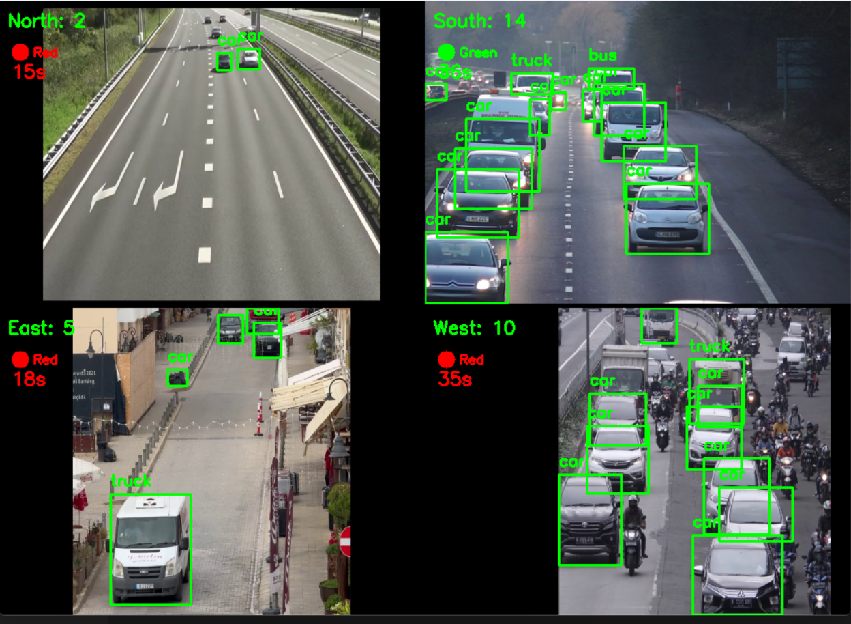
Figure 7: User Interface

When the application runs, a single window appears showing a 2x2 grid of the video feeds. Each feed includes the following:
- Direction and Vehicle Count: Displayed at the top-left of each frame (e.g., north: 5).
- Signal Light: A red or green circular indicator overlaid on the frame, showing the current signal status.
- Signal Timer: Shows time remaining for the green signal or the preset time for red signals, updated in real-time. The timer is green when active and red otherwise.
The system adjusts green signal durations based on the ratio of vehicles in each direction (min 15s, max 60s). If an emergency vehicle is detected in any direction, that direction is immediately prioritized for the green signal. After handling emergencies, normal rotation resumes.
The interface updates live and resets video feeds automatically when they reach the end. Press Q to exit the application.
This user-friendly UI is suitable for both testing and live intersection simulation.

Project QR CODE (GITHUB REPOSITORY):



